**COMPONENT 4**

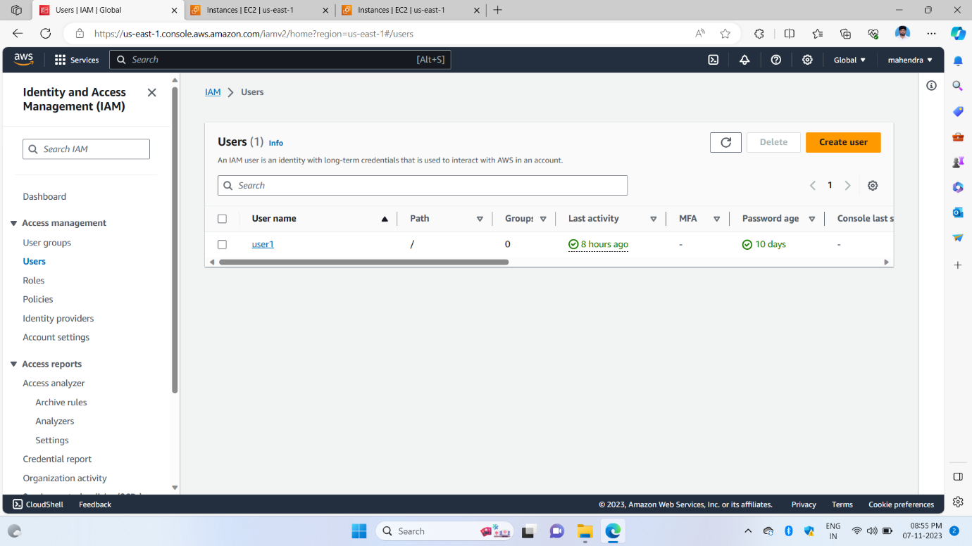

1st image shows the start of component 4 created a user in the IAM service of AWS this created a user for accessing the CLI using AWS configuring to access anywhere this service of uploading and changing in the AWS account

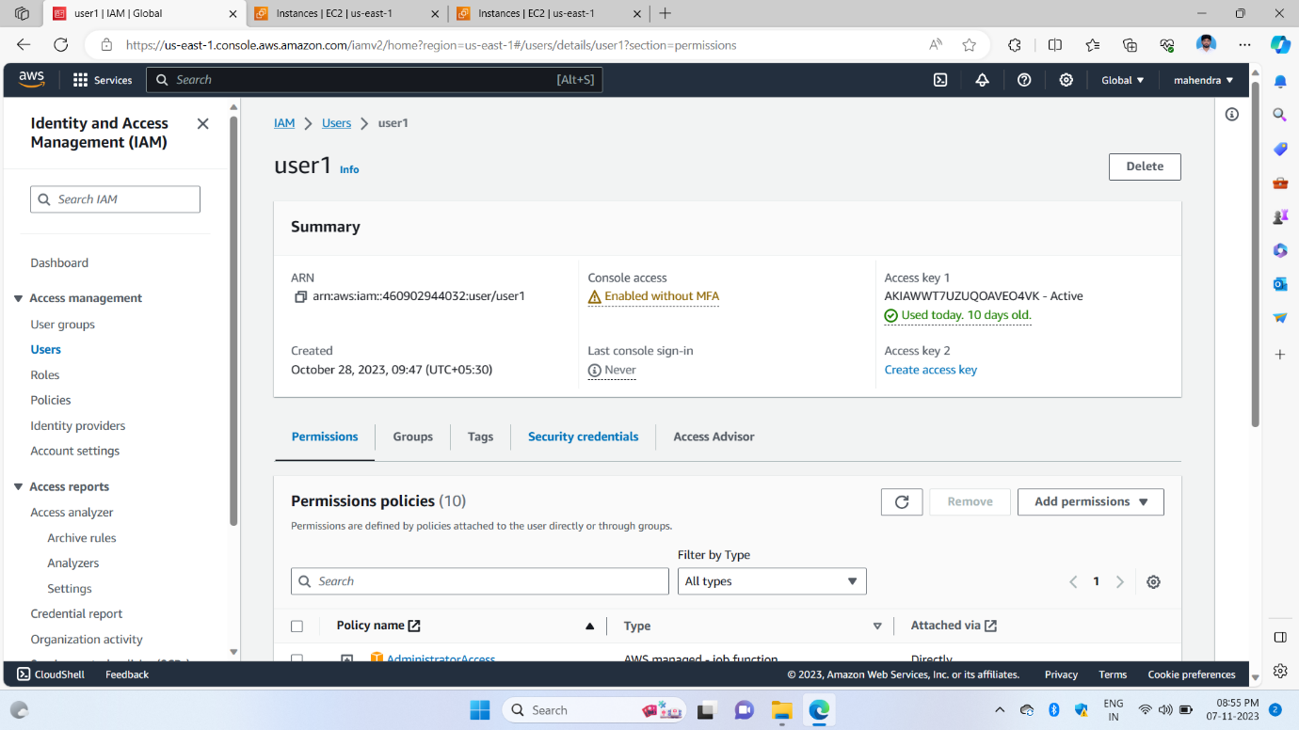

2nd image of showing in inside the IAM user in this we have given permission for another person to use, or I am only using some other terminals for the purpose of accessing that service and creating an access key we can do this part

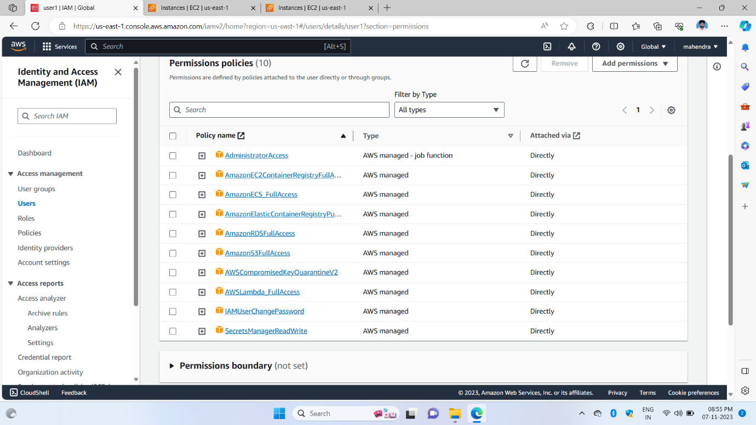

3rd image shows all the services attached in user can use only these services and not other services

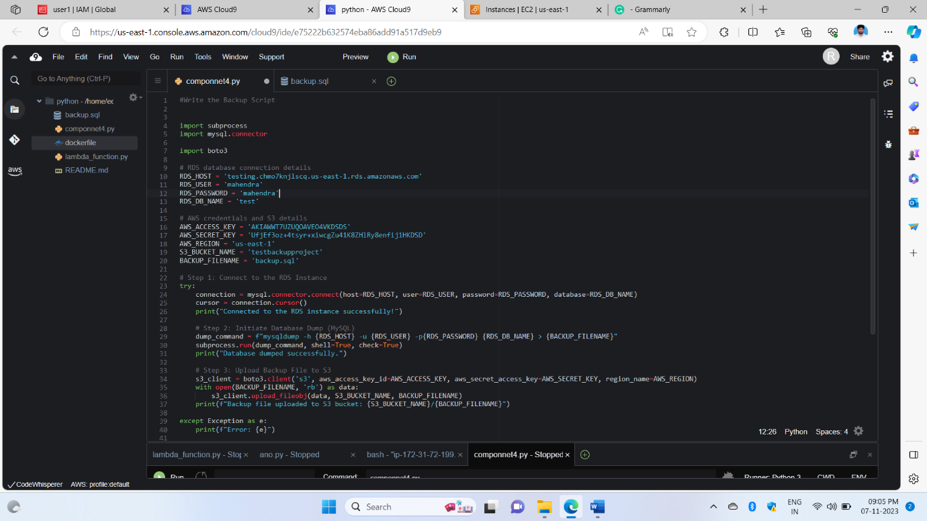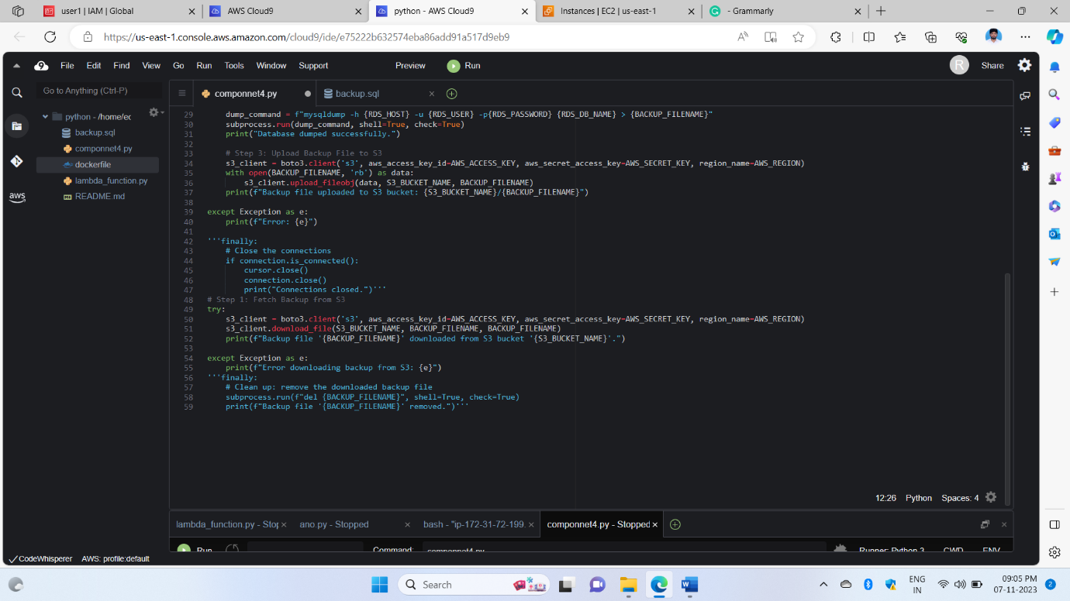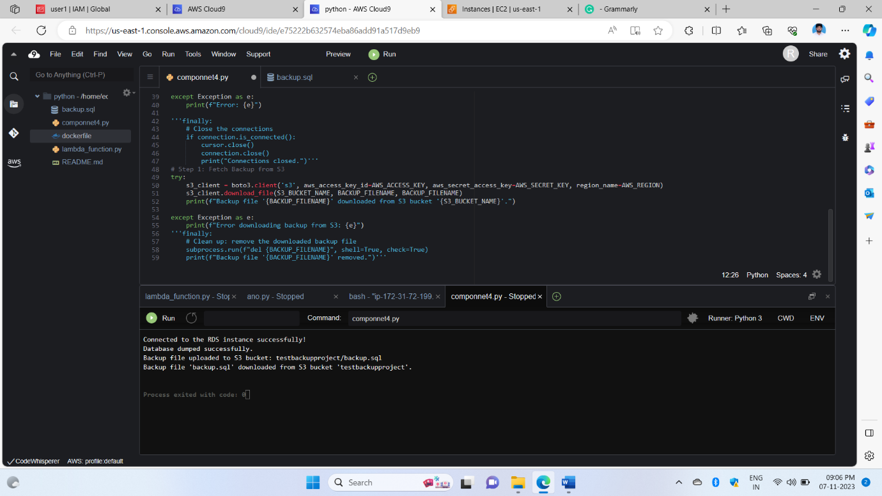

4th, The 5th, and 6th images show for execution of the code in the language Python main goal of the code is to connect the database of RDS to MySQL this Python code and connect the s3bucket code we used mainly two libraries for boto3 for s3 and MySQL.conennector for this is RDS and uploading object inside the bucket of s3 and RDS stored database combined with uploading in bucket and restoring like downloading the bucket inside of object to our local environment

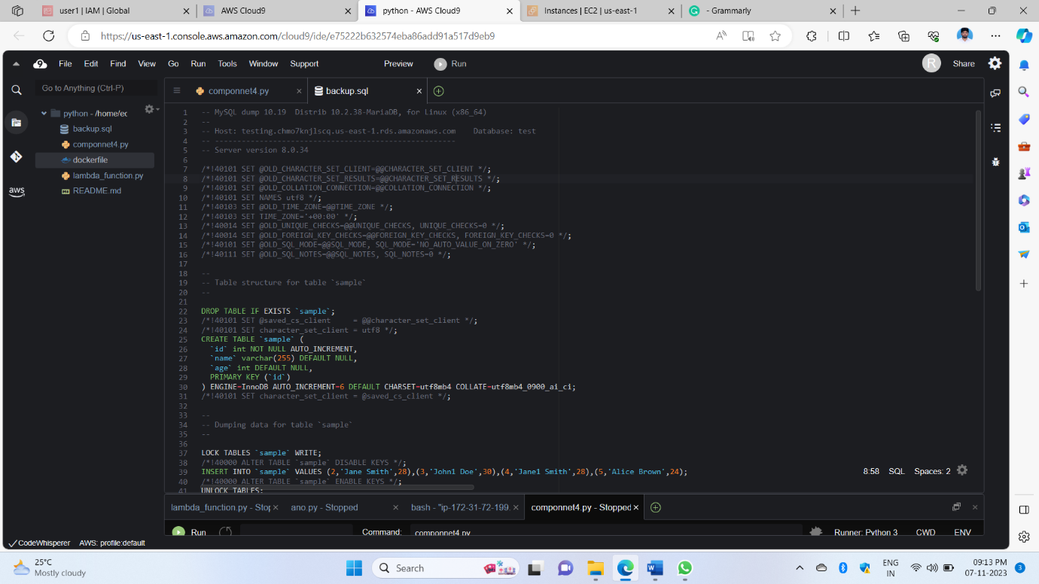

7th image shows this code is downloaded from an s3 bucket this combination of RDS stored queries combined with the previous code and took a name backup SQL file like uploaded and downloaded

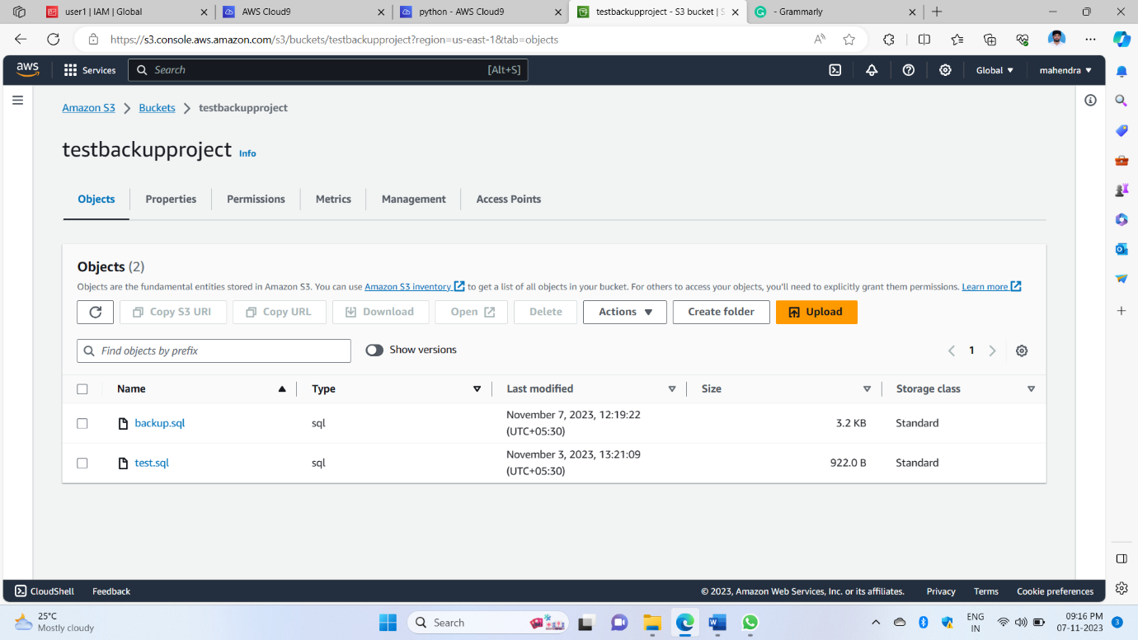

8th image showing with the help of Python code in the s3 bucket uploaded object

In component 4 entire thing is we have to write a code in Python script upload the object and restore the object for this, we use IAM user policies and database connections like botoo3 MySQL connector and OS with this help we can complete the componnet4 that downloaded backup file stores in our local environment it’s all depend on AWS cli and python code